# **Summer 2023**

# **CSE 221 Lab Final**

**Set A**

**Total Marks: 20**

**Time: 1 hour**

**Name:**

**ID:**

Bob is a con guy and after completing a con job he is running away from the police. After some moment, the number of police chasing him increased. For a successful escape he needs to distract policemen. In order to do so, he decided to enter into a maze which looks like the graph given below.

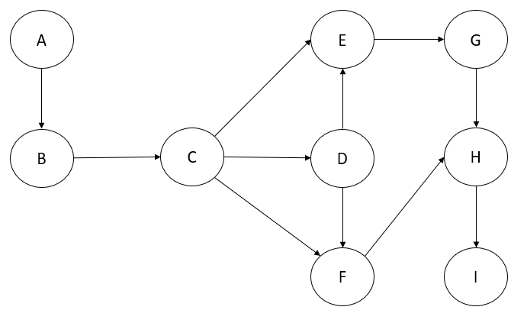

In this maze, Bob’s entry point is A and there is only one exit point which is I. Bob has to successfully reach out to the exit point from the entry point by distracting the police successfully inside the maze and ensure a successful escape for him.

**Q1 (Marks 2):** Read the inputs of the graph from a text (.txt) file following the given format.

**Q2 (Marks 4):** Show inputs (which you have taken from the text file) in the adjacency matrix or adjacency list in order to represent the graph.

**Q3 (Marks 9):** Apply a suitable algorithm by which Bob will be able to find a way out of the maze. Which means the algorithm will provide a way to reach the exit point I from the entry point A. Once Bob reaches the exit point I, the algorithm will be terminated.

**Q4 (Marks 5):** Somehow, some policemen predicted earlier that Bob is going to apply this technique for a successful escape and they are waiting for Bob inside the maze at point D and Bob just got the information just after arriving at the entry point A of the maze. Which means, now Bob has to avoid the paths which are connected with point D for reaching the exit point I. In this case, apply a suitable algorithm and find out a way according to the problem statement given above, by which Bob will be able to reach the exit point I from entry point A by dodging policemen who are waiting at point D without changing inputs of the graph.

| **Sample Input** | **Sample Output** |
| --- | --- |
| 9 #number of vertices  11 #number of edges  A^B  B^C  C^D  C^E  C^F  D^E  D^F  E^G  F^H  G^H  H^I | #Output of Q3:  A, B, C, E, G, H, I  Or,  A, B, C, D, E, G, H, I  Or,  A, B, C, D, F, H, I  Or,  A, B, C, F, H, I  #Output of Q4:  A, B, C, E, G, H, I  Or,  A, B, C, F, H, I |